

Medication Adherence Tracker for Elderly Patients
A CASE STUDY ANALYSIS REPORT
Submitted in the partial fulfilment for the Course of
CSA1012-Software Engineering
to the award of the degree of
BACHELOR OF TECHNOLOGY
IN
Artificial Intelligence
Submitted by
P SADVIK(192472243)
Under Supervision of
Dr. k Anita Davamani
SIMATS ENGINEERING
Saveetha Institute of Medical and Technical Sciences
Chennai-602105
AUGUST-2026

ABSTRACT
The Medication Adherence Tracker for Elderly Patients with Caregiver Alerts is a user-friendly digital healthcare application designed to support elderly patients who manage multiple medications and dosing schedules. The proposed system addresses missed, delayed, or incorrectly recorded doses by combining medication scheduling, patient reminders, simplified confirmation, adherence monitoring, caregiver dashboards, missed-dose escalation, and refill notifications in one platform. The interface emphasizes elderly usability through large text, clear icons, minimal navigation, and simplified interaction. Caregivers can manage medication schedules and remotely monitor adherence information, while the alert mechanism can notify caregivers when a dose remains unconfirmed beyond a defined threshold. The technical implementation demonstrates software engineering practices using Git for version control and Docker for reproducible containerized deployment. Git branches isolate features and maintain a traceable development history, while Docker and Docker Compose separate the application and database services into manageable containers. The proposed architecture provides a scalable foundation for future integration with pharmacies, healthcare providers, smart medication devices, and additional remote-monitoring services. Overall, the project aims to improve medication-management coordination, provide caregivers with faster visibility into adherence issues, and support safer independent living for elderly patients.
Keywords: Medication adherence, Elderly patients, Caregiver alerts, Medication reminder, Remote monitoring, Git, Docker, Docker Compose, Healthcare application.

1. Problem Analysis

1.1 Industry Context
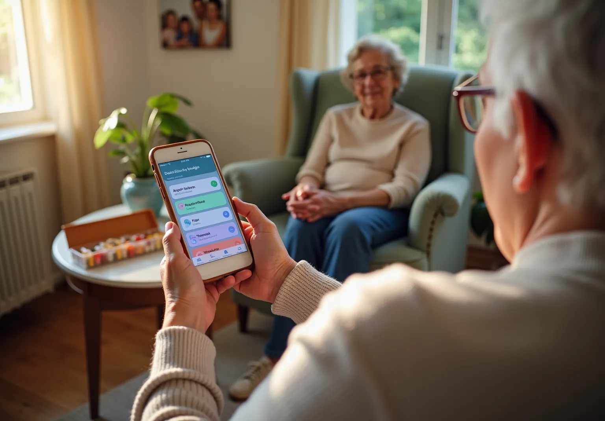
Figure 1. Digital medication support and caregiver monitoring for an elderly patient.
The healthcare industry is witnessing a rapidly aging population, and elderly patients increasingly manage multiple chronic conditions requiring complex medication schedules. Medication non-adherence can result in missed or incorrectly timed doses and may contribute to preventable complications and healthcare costs.
Many elderly patients live independently or with limited caregiver supervision. Memory problems, cognitive decline, multiple prescriptions, and complicated dosing schedules make medication management difficult. Digital health and remote monitoring tools can bridge the gap between patients and caregivers who are not physically present.

1.2 Problem Statement
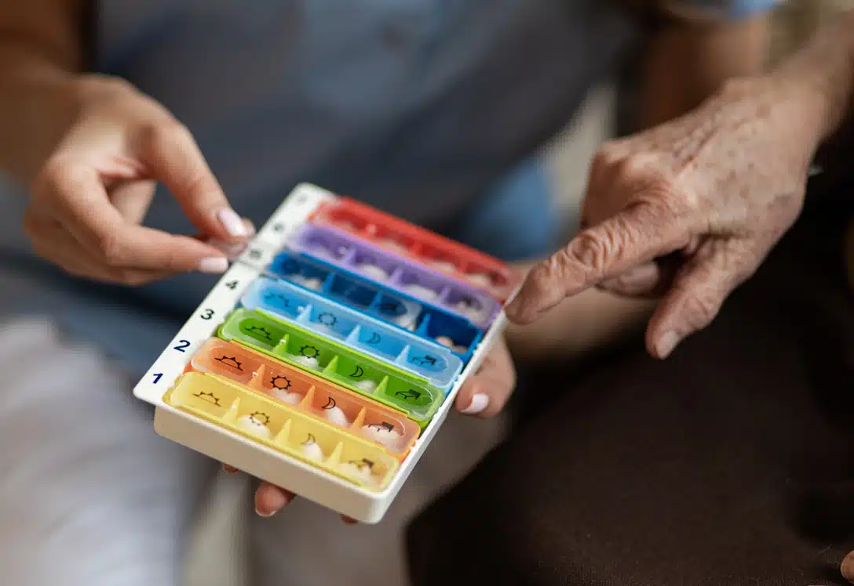
Figure 2. Traditional pill organization illustrates the need for clearer digital scheduling and tracking.
Elderly patients often struggle to remember complex medication schedules. Caregivers may have no reliable way to know whether a dose was taken. Traditional pill organizers and paper reminders do not provide remote monitoring or immediate escalation when a dose is missed.
The proposed platform combines medication scheduling, patient reminders, simplified confirmation, adherence tracking, caregiver visibility, missed-dose detection, escalation alerts, and refill reminders.

1.3 Objectives
- Design an elderly-friendly interface using large text, clear icons, and minimal navigation.
- Provide medication scheduling for multiple drugs and dosing times.
- Generate reminders when medications are due.
- Provide a caregiver dashboard showing adherence history and missed-dose alerts.
- Escalate alerts when a dose remains unconfirmed beyond a threshold.
- Support simplified or voice-based medication confirmation.
- Provide refill reminders when medication supplies are low.
- Protect patient information through authentication and access control.

1.4 Expected Outcomes
- Improved medication adherence.
- Reduced missed doses and delayed caregiver awareness.
- Greater patient independence.
- Faster response to adherence problems.
- Better coordination among caregivers.
- Scalable foundation for future healthcare integrations.

2. Project Structure Design

2.1 Repository Structure
medication-adherence-tracker/
├── frontend/
│ ├── index.html
│ ├── login.html
│ ├── patient-dashboard.html
│ ├── caregiver-dashboard.html
│ └── css/style.css
├── backend/
│ ├── app.py
│ ├── routes/
│ │ ├── auth.py
│ │ ├── medication.py
│ │ ├── patient.py
│ │ └── caregiver.py
│ ├── services/
│ │ ├── reminder_service.py
│ │ ├── alert_service.py
│ │ └── refill_service.py
│ └── database/db.py
├── database/schema.sql
├── tests/
├── docs/
├── screenshots/
├── .gitignore
├── Dockerfile
├── docker-compose.yml
├── requirements.txt
└── README.md

2.2 Folder Responsibilities
Folder/File | Purpose
frontend/ | Patient and caregiver interface.
backend/ | Server-side logic and APIs.
routes/ | Authentication and application request handlers.
services/ | Reminder, alert, escalation and refill logic.
database/ | SQL schema and database configuration.
tests/ | Automated and functional tests.
docs/ | Architecture and workflow documentation.
screenshots/ | Evidence for Git and Docker operations.
Dockerfile | Application container image definition.
docker-compose.yml | Application and database service configuration.
README.md | Setup, usage and technical instructions.

2.3 System Architecture Diagram
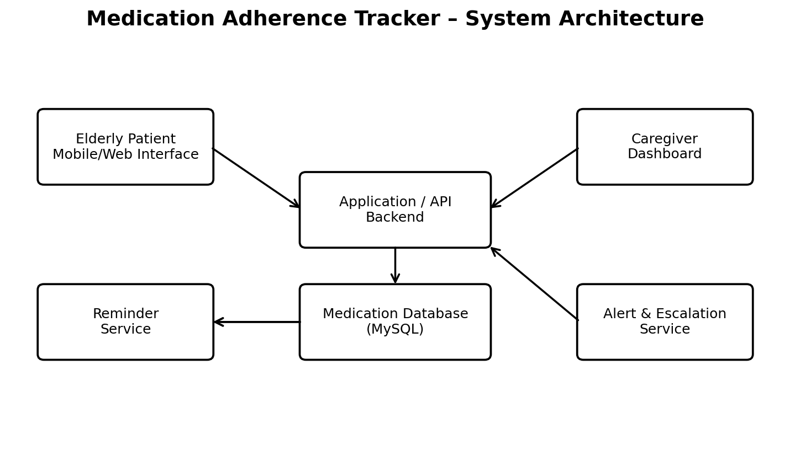
Figure 3. Proposed architecture showing patient/caregiver interfaces, backend services, database, reminders and alerts.

3. Git Repository Initialization

3.1 Repository Creation
Git is used to maintain source-code history, coordinate development, and support controlled changes.
mkdir medication-adherence-tracker
cd medication-adherence-tracker
git init

3.2 Configuration
git config --global user.name "Student Name"
git config --global user.email "student@example.com"
git status

3.3 Initial Commit
git add .
git commit -m "Initial project structure"
git log --oneline

3.4 .gitignore
__pycache__/
*.pyc
.env
.vscode/
.idea/
node_modules/
The .gitignore file is important because configuration files and generated files should not unnecessarily enter version control. Sensitive credentials should be kept outside the repository.

3.5 Git Repository Lifecycle
Working Directory
↓
git add
↓
Staging Area
↓
git commit
↓
Local Repository
↓
git push
↓
Remote Repository

4. Git Branching Strategy

4.1 Selected Strategy
The project uses a Main–Development–Feature branching model. The main branch represents stable software. Development integrates completed features, while feature branches isolate individual modules.
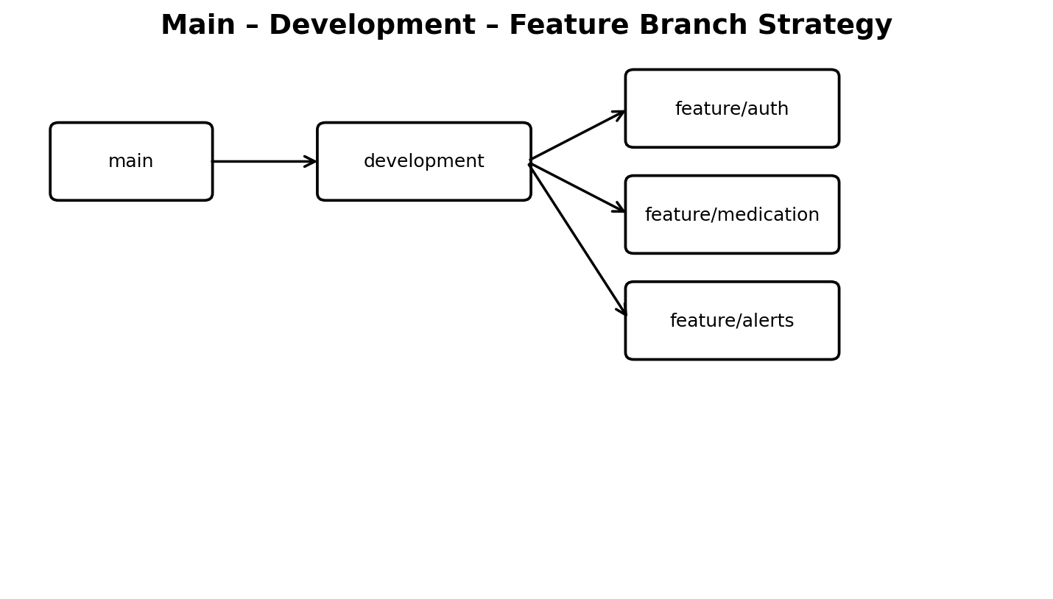
Figure 4. Branching strategy for the project.

4.2 Branch Commands
git checkout -b development
git checkout -b feature/authentication
git checkout -b feature/medication
git checkout -b feature/reminder
git checkout -b feature/caregiver-alert

4.3 Justification
- Prevents unfinished features from directly affecting the stable branch.
- Allows separate development of authentication, medication, reminders and alerts.
- Provides a controlled integration point through development.
- Makes the history easier to review and maintain.

5. Version Control Workflow
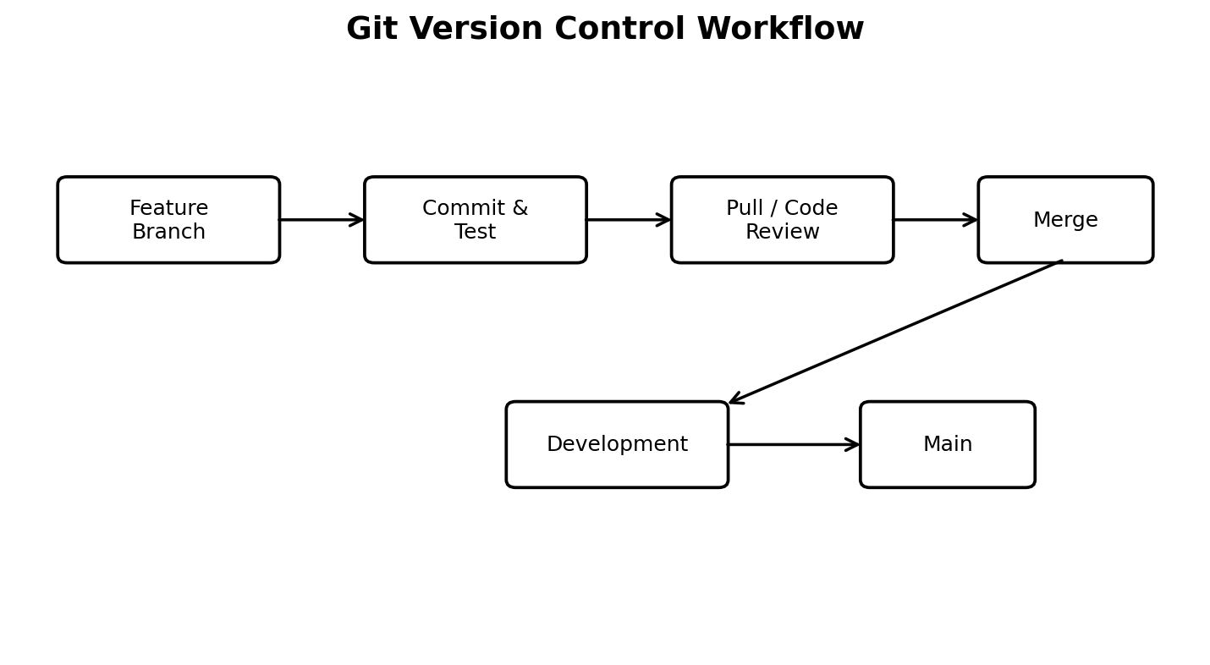
Figure 5. Git workflow from feature development through testing, review and merging.5. Version Control Workflow – Continued

5.1 Meaningful Commits
git add .
git commit -m "Implement user authentication"
git commit -m "Add medication scheduling module"
git commit -m "Implement medication reminder service"
git commit -m "Add caregiver alert functionality"
git commit -m "Add adherence dashboard"
git commit -m "Add Docker configuration"

5.2 Merge
git checkout development
git merge feature/medication
After integration testing, the stable development version can be merged into main.

5.3 Repository Synchronization
git pull origin development
git push origin development

5.4 Conflict Resolution
If Git reports a conflict, the developer inspects the affected files, resolves conflicting sections, stages the corrected files, and commits the resolution.
git status
# resolve conflicting file
git add .
git commit -m "Resolve merge conflict"

6. Commit History Analysis

6.1 Sample History
a821f45 Add Docker configuration
c392a11 Add caregiver alert functionality
b832e21 Implement medication reminder service
a761d34 Add medication scheduling module
f641c20 Implement authentication
e521a10 Add initial project structure

6.2 Good vs Poor Messages
Good | Poor
Add medication scheduling module | update
Implement missed-dose detection | changes
Add caregiver alert service | final
Fix dashboard layout | new

7. Docker Environment Design
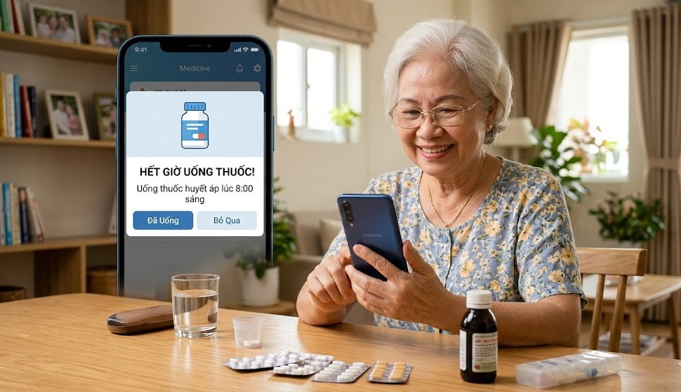
Figure 6. Smartphone-based medication reminder concept for elderly users.

7.1 Why Docker is Suitable
Docker provides a consistent runtime environment for the application and its dependencies. The project can separate application logic and database storage into independent containers, reducing environment-related configuration problems.

7.2 Components Requiring Containerization
- Backend/application service.
- MySQL database service.
- Optional future notification worker.
- Optional reverse proxy/frontend service.
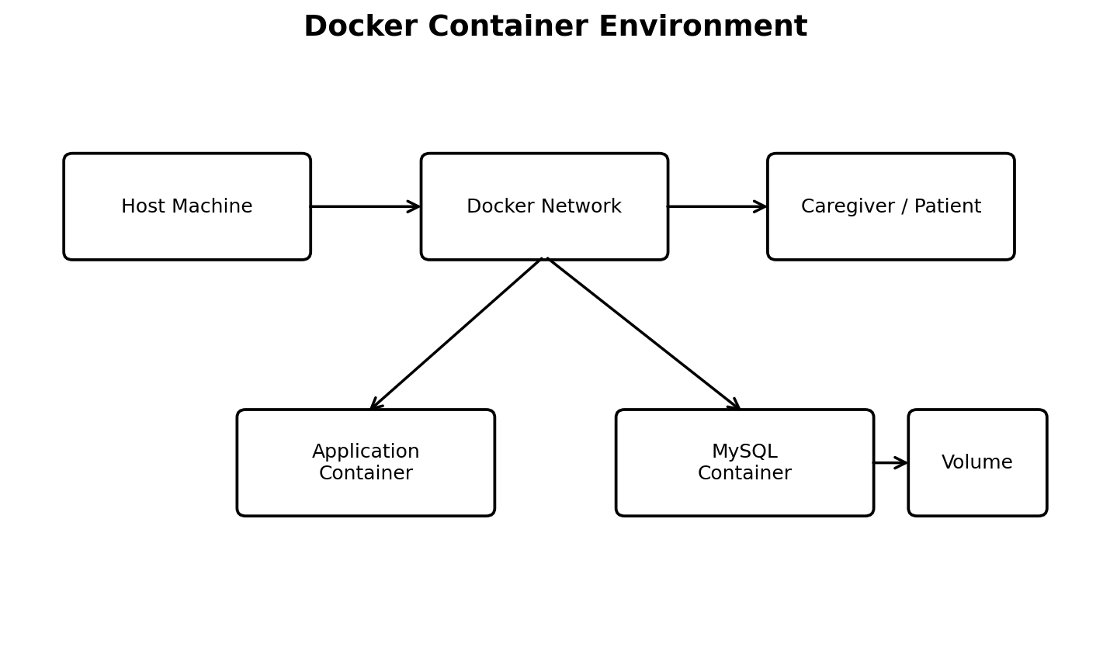
Figure 7. Docker environment showing application and database containers connected through a network.

7.3 Container Responsibilities
Container | Main Responsibility
medication_app | Runs backend APIs, scheduling, reminders, adherence and caregiver-alert logic.
medication_database | Stores patient, medication, schedule, adherence and alert records.

7.4 Containerization Benefits
- Portability across development machines.
- Isolation of application and database services.
- Repeatable deployment.
- Simpler dependency management.
- Foundation for future scaling.
8. Dockerfile Development

8.1 Dockerfile
FROM python:3.11-slim
WORKDIR /app
COPY requirements.txt .
RUN pip install --no-cache-dir -r requirements.txt
COPY backend/ .
EXPOSE 5000
CMD ["python", "app.py"]

8.2 Instruction Explanation
Instruction | Purpose
FROM | Selects the Python base image.
WORKDIR | Sets the working directory.
COPY | Copies dependencies and source code into the image.
RUN | Installs required packages.
EXPOSE | Documents the application port.
CMD | Starts the application.

8.3 Build and Run
docker build -t medication-tracker .
docker run -p 5000:5000 medication-tracker

8.4 Verification
docker images
docker ps
docker logs medication_app
A successful build produces the medication-tracker image. A running container should expose the configured application port and provide logs without fatal startup errors.
9. Docker Compose Design

9.1 Compose Configuration
services:
app:
build: .
container_name: medication_app
ports:
- "5000:5000"
depends_on:
- db
environment:
DB_HOST: db
DB_NAME: medication_db
DB_USER: medication_user
DB_PASSWORD: medication_password
db:
image: mysql:8.0
container_name: medication_database
restart: always
environment:
MYSQL_DATABASE: medication_db
MYSQL_USER: medication_user
MYSQL_PASSWORD: medication_password
MYSQL_ROOT_PASSWORD: root_password
volumes:
- mysql_data:/var/lib/mysql
volumes:
mysql_data:

9.2 Services, Networking and Volumes
Element | Explanation
app service | Builds and runs the application container.
db service | Runs MySQL database.
depends_on | Expresses application-to-database startup dependency.
network | Allows services to communicate by service name.
volume | Provides persistent database storage.
environment | Provides runtime configuration.

9.3 Database Communication
The application should use DB_HOST=db because 'db' is the Compose service name. Using localhost inside the application container would incorrectly refer to the application container itself.

9.4 Security Note
In a real deployment, passwords and API keys should be managed with secure environment configuration or secrets rather than being committed to a public repository.
10. Container Deployment and Testing

10.1 Deployment Commands
docker compose up --build
docker compose up -d --build
docker compose ps
docker ps
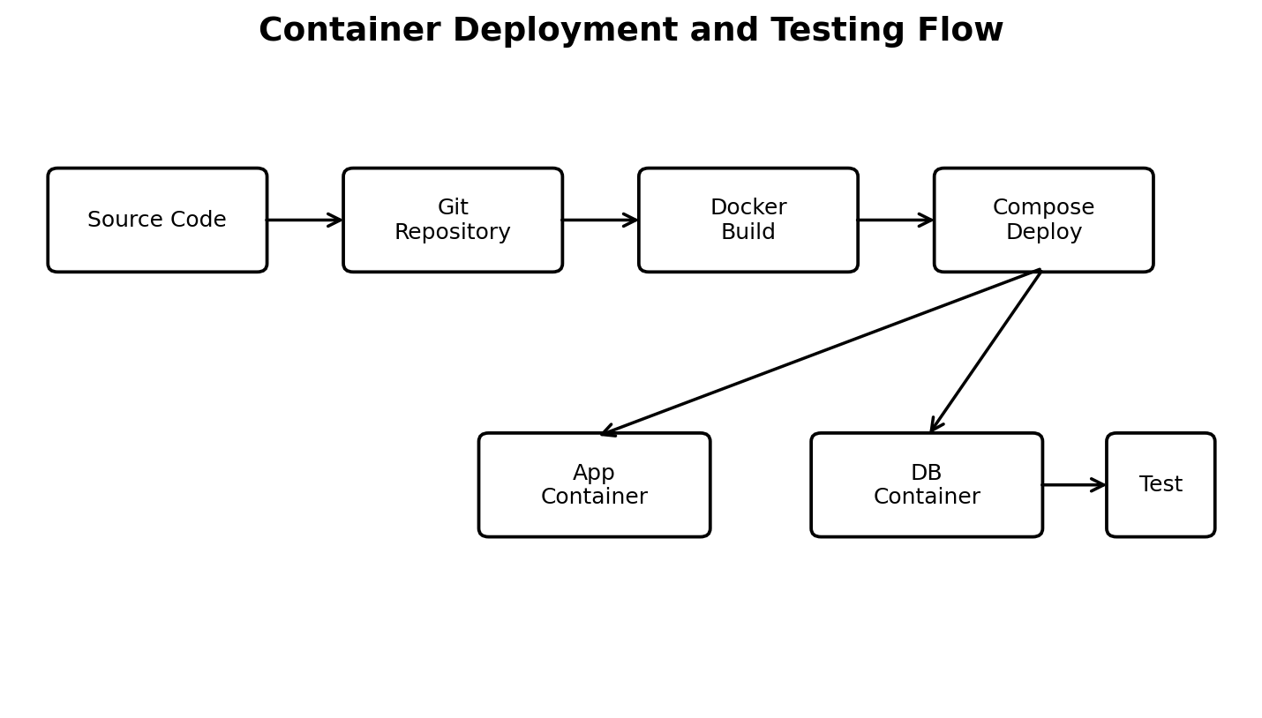
Figure 8. Deployment flow from source code and Git repository through Docker build, Compose deployment and testing.

10.2 Logs and Access
docker compose logs app
docker compose logs db
http://localhost:5000

10.3 Functional Testing
Test ID | Scenario | Expected Result
TC01 | Valid patient login | Patient dashboard opens.
TC02 | Caregiver adds medication | Medication record is saved.
TC03 | Medication schedule reaches due time | Reminder is generated.
TC04 | Patient confirms dose | Dose status becomes Taken.
TC05 | No confirmation within threshold | Dose becomes Missed.
TC06 | Missed dose | Caregiver receives alert.
TC07 | Medication quantity low | Refill reminder is generated.
TC08 | Database operation | Expected record is stored/retrieved.
TC09 | Container restart | Services restart successfully.

10.4 Reminder and Alert Sequence
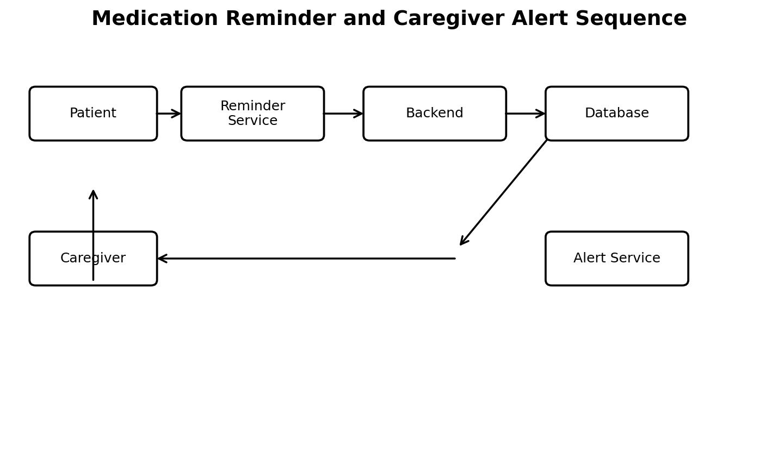
Figure 9. Simplified sequence for reminder, backend processing, database status and caregiver alert.
11. Benefits of Git and Docker

11.1 Git Benefits
Benefit | Application to Project
Version management | Tracks every major change to the healthcare application.
Collaboration | Allows multiple contributors to work through branches.
Traceability | Connects features and fixes to commit history.
Rollback | Allows recovery of earlier stable versions.
Controlled release | Main can be kept stable while development continues.

11.2 Docker Benefits
Benefit | Application to Project
Portability | Same containerized environment can be reproduced.
Isolation | Application and database run as separate services.
Deployment | Compose starts the complete system with one workflow.
Maintainability | Services and dependencies are clearly separated.
Scalability | Containerized application provides a base for future scaling.

11.3 Combined Workflow
Developer
↓
Git Feature Branch
↓
Commit + Test
↓
Merge to Development
↓
Docker Build
↓
Compose Deployment
↓
Container Testing
↓
Stable Main / Release

11.4 Relevance to Healthcare Application
Git helps maintain traceability of software changes, while Docker supports consistent execution of the application and database. These practices are valuable for a system that handles medication schedules, adherence records and caregiver notifications.

Conclusion

The Medication Adherence Tracker for Elderly Patients with Caregiver Alerts provides a practical software solution for medication scheduling, reminders, adherence tracking, missed-dose detection, caregiver alerts, escalation and refill support. Its design emphasizes elderly usability and remote caregiver visibility.
The project demonstrates the application of Git and Docker concepts required by the CO3 technical assignment. Git provides version control, branching, collaboration and history, while Docker and Docker Compose provide reproducible containerized deployment for the application and database.
The architecture and workflow presented in this report provide a scalable foundation for future improvements such as cloud deployment, smart-device integration, voice interaction and authorized healthcare-system integration.

